###### *St Pius X Catholic Parish Heidelberg West acknowledges the Wurundjeri people*.

Fr Wayne Edwards: St Pius X Presbytery 419 Waterdale Rd Heidelberg West 3081

Tel: 9457 5794 Fax: 9457 1036 Email: heidelbergwest@cam.org.au

Exodus Community: 273 Liberty Parade Heidelberg West Tel: 9457 7593

School Principal: Barbara Gomez Tel: 9457 3776 Email: bgomez@spxhw.catholic.edu.au

_________________________________________________________________________________________________

MASS TIMES

Sundays Saturday Vigil 7pm Sunday 9am & 11.00am

Exodus Community, 12 Noon in the shed at 273 Liberty Pde, Heidelberg West

Weekdays 9am Tuesday, Wednesday, Thursday, Friday, Saturday

CONFESSIONS & ROSARY After 9am Mass on Saturday mornings

CHURCH OPEN FOR PRAYER 8.30am – 4pm on school days only

PARISH WEBSITE - pol.org.au/heidelbergwest

*St Pius X Catholic Church Heidelberg West actively works to listen to, empower and protect children, and has zero tolerance for child abuse and neglect*.

PLEASE LOOK AFTER YOUR CHILDREN WHILE MASS IS IN PROGRESS

**SAINTS/FEAST DAYS FOR THE WEEK**

* *Monday 26 – St Stephen*
* *Tuesday 27 – St John*
* *Wednesday 28 – The Holy Innocents*
* *Thursday 29 – 5th day in the Octave of the Nativity of the Lord*
* *Friday 30 – The Holy Family of Jesus, Mary and Joseph*

***Reflection****:**And the Word became flesh and made his dwelling among us…”John 1:14*

God made us to be in relationship with Him. He loves each of us individually. Through sin, our relationship with God was broken. He gave us Jesus to restore our relationship. Being a disciple of Jesus we are given the model to obtain eternal life in Heaven. Christmas isn’t about the material gifts we receive, it’s about the love that God, Our Father, gave us by giving us His Son, Jesus – the best gift we could ever receive.

**Next Sunday**: January 1st

|  |  |  |
| --- | --- | --- |
|  | **Reader** | **Special Ministers** |
| Saturday 7:00pm | Peter Overton |  |
| Sunday 9:00am | Volunteer |  |
| Sunday 11:00am | Jennifer Lim |  |

**NEXT SUNDAY’S READING – MARY THE HOLY MOTHER OF GOD**

Num 6: 22-27; Ps 66: 2-3, 5, 6, 8; Gal 4: 4-7; Lk 2: 16-21

**C:\Users\Parish\AppData\Local\Microsoft\Windows\Temporary Internet Files\Content.IE5\OEK841P7\MC900363562[1].wmf**

***ADVENT & CHRISTMAS 2022***

***New Year’s Day, Sunday***

Normal Sunday Mass Times

Solemnity Mary Mother of God

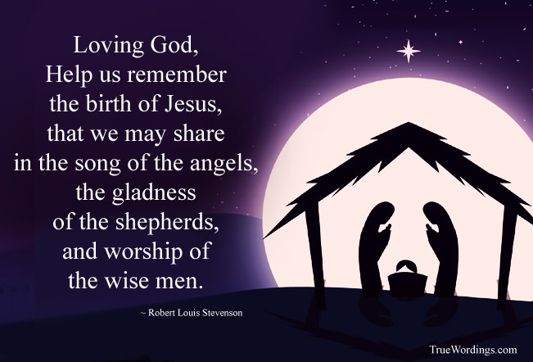EXPERIENCE TAIZE

Friday 30th January, 6pm-7pm at St Pius X Church. Come and experience this calming, quieting, welcome respite from the hustle and bustle of life….

All are welcome! Light supper will be provided after prayer.

**ST VINCENT DE PAUL THANK YOU!** C:\Users\Parish\AppData\Local\Microsoft\Windows\Temporary Internet Files\Content.IE5\Q7UQF7TR\MC900410591[1].wmf

St Vincent De Paul Society would like to thank you for your generosity with donations of groceries and other items for the Christmas Hampers. Much appreciated!

**SENIORS GET TOGETHER - JANUARY**

. ***All seniors (over 55) are more than welcome to join us at our monthly gatherings****.* Join us Wednesday 18th January more details to follow.

**PILGRIMAGE TO THE HOLY LAND**

The Parish of Ivanhoe has a couple of vacancies for its Parish Pilgrimage to the Holy Land 11th – 28th April 2023. If you are interested please visit our Parish Website [www.melbcatholic.org/ivanhoe](http://www.melbcatholic.org/ivanhoe) and click on the News Page or phone Fr. Bill Edebohls 0427 879 733.

***Prayers for the Sick***; Pauline Curlis

***For the recently departed:*** *Hoang Nguyen, Genevieve Slattery, Maureen Brown, Fr Joseph Hynan*

***Anniversary of Death***: Margaret McNamara, Dorothy Hempenstall, Michelle Callahan, Betty Scannell, Winifred Evans